Boy Scout TROOP 204 in Bethesda: Join us!
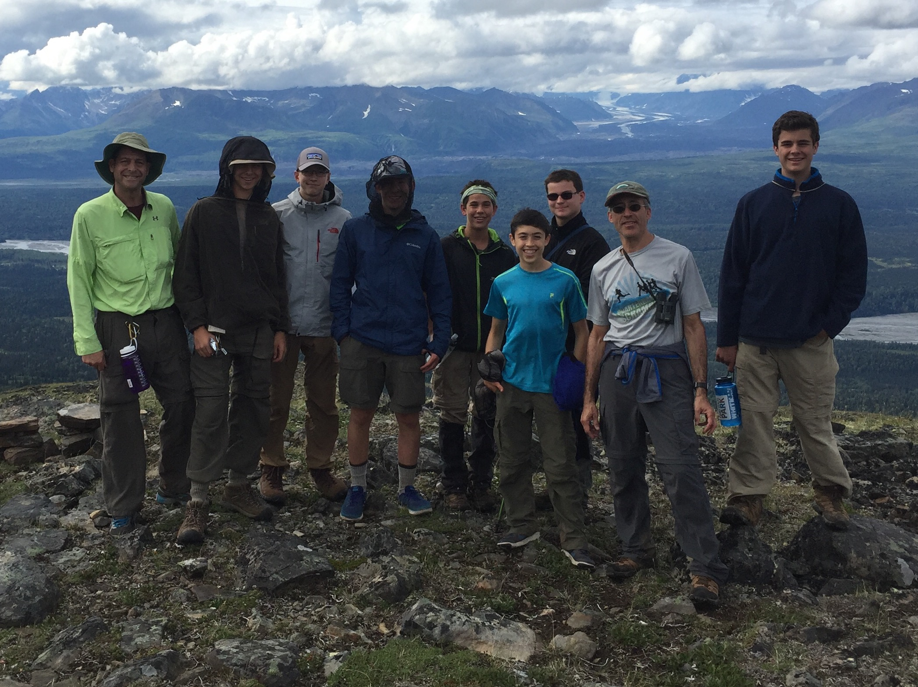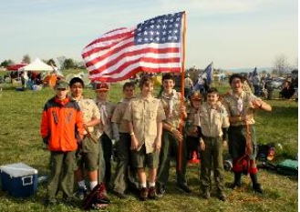
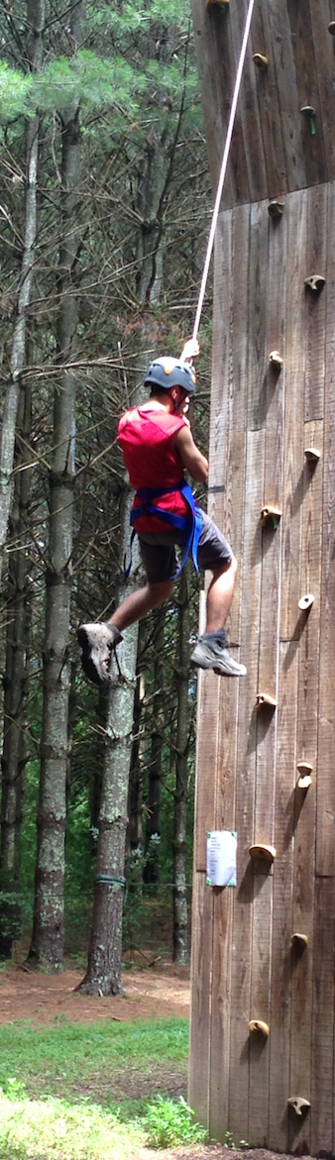
Our Troop is one of the oldest Boy Scout troops in Montgomery County- over 80 years strong! We are an active Troop and maintain a roster of nearly 30 boys ranging in age between 11 and 17. We generally camp once a month and support our community with a variety of volunteer activities throughout the year.

FUN OUTDOOR ACTIVITIES:
beach camping , skiing, backpacking, caving, rafting, biking, riflery, canoeing, orienteering

HIGH ADVENTURE!!:
Florida keys as part of the Coral Reef Sea Base High Adventure sailing trip.
Philmont Scout Ranch in New Mexico
Hiking and camping near Denali National Park, Alaska
Philmont Scout Ranch High Adventure
Canoeing on the Northern Tier High Adventure in Ontario, Canada

WINTER/SPRING 2017 SCHEDULE
● Jan. 27-29, 2017: Klondike Derby winter camping, Little Bennett State Park, MD
● Feb. 10-12, 2017: family ski trip to Timberline ski resort, W.Va.
● March 3-5, 2017: hiking/camping at Marsden Tract, C&O Canal, MD
● April 1-2, 2017: caving campout
● May 6-7, 2017: hiking/camping near Old Rag mountain, Shenandoah Nat’l Park, VA
● June 2-4, 2017: rafting/biking at Ohiopyle State Park, PA

THE BASICS
- MEETINGS: During the school year, Troop 204 meets every Wednesday at 7:30 – 8:45 p.m. in the Scout Room at Bethesda United Methodist Church at 8300 Old Georgetown Rd at the corner of Old Georgetown Rd. and Huntington Parkway.
- WEB SITE: Our primary source of communication is via our web site at: http://troop204bethesda.scoutlander.com. Please let us know if you have any trouble logging in. Parents will be given accounts and full access to the site.
- ANNUAL DUES: $175 and include your son’s membership with the local scout council, insurance fees, a subscription to Boys Life magazine, and contribution to troop activities.
- CONTACTS: Jeff Popkin, Scoutmaster (jspop@mac.com)
Gary Davis, Ass’t Scoutmaster (gary.t.davis@nasa.gov)
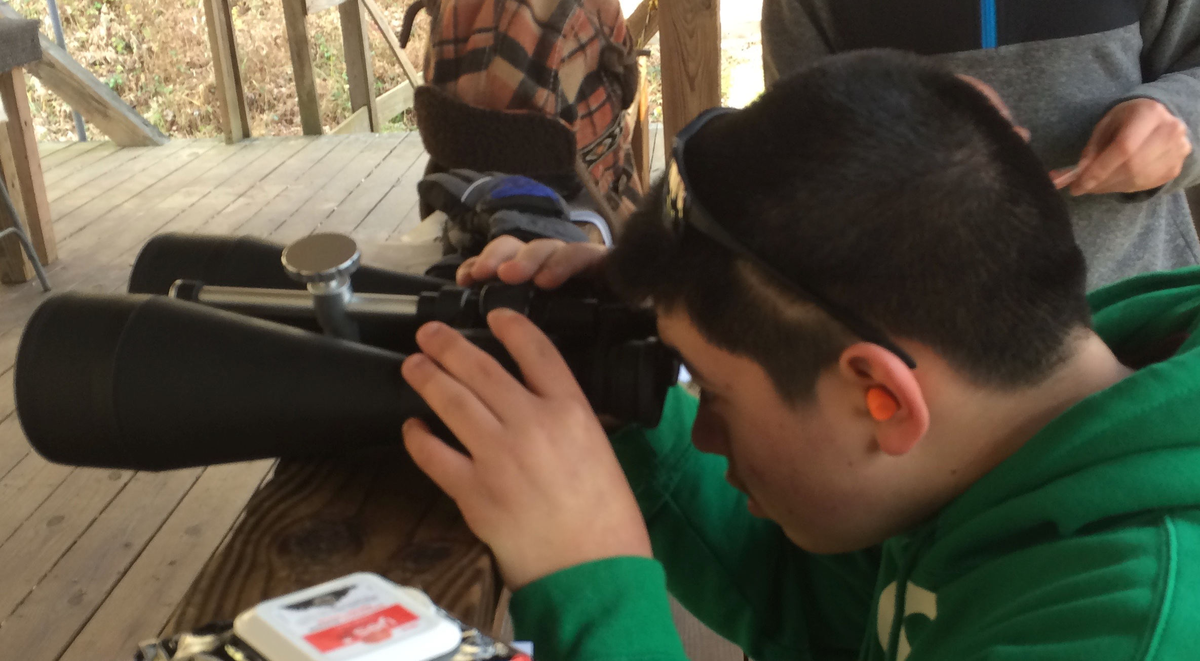
John O’Boyle, Ass’t Scoutmaster (jdoboyle@aol.com)
Michael Bergman, Committee Chairman (mbergman@ftc.gov)

Come look into Scouting - Check out Troop 204!

